Flight Reservation System Documentation

# Introduction

The Flight Reservation System is a simple yet efficient software that allows users to book and manage domestic flight tickets. The system displays a list of available flights, allows seat selection, and handles the booking process. It also features the ability to cancel bookings and displays real-time availability of seats.

# Requirements and Software Used

The Flight Reservation System is built using the following software and tools:  
1. Python - The primary programming language used to develop the application.  
2. Tkinter - A standard GUI toolkit for Python, used to create the user interface for the application.  
3. Deque - A data structure from Python's collections module to handle waitlists efficiently.  
4. Python-docx - A Python library to generate Microsoft Word documents, used to create this documentation.

# Features

1. Flight Selection: View a list of available flights with details like departure, destination, and pricing.
2. Seat Booking: Select up to 8 seats per booking with real-time seat availability updates.
3. Dynamic Seat Layout: Displays seat availability in green (available) or red (booked).
4. Booking and Cancellation: Confirm bookings and cancel the last reservation made

# Technology

The technology stack behind the Flight Reservation System includes:  
1. Python Programming Language: The backend logic and functionality of the system are built using Python.  
2. Tkinter GUI Toolkit: Tkinter is used to design the graphical interface of the application.  
3. Collections Deque: The deque is used to manage the waitlist of passengers, ensuring fast access and updates.  
4. Object-Oriented Programming (OOP): The system is designed using OOP principles for better structure and maintainability.

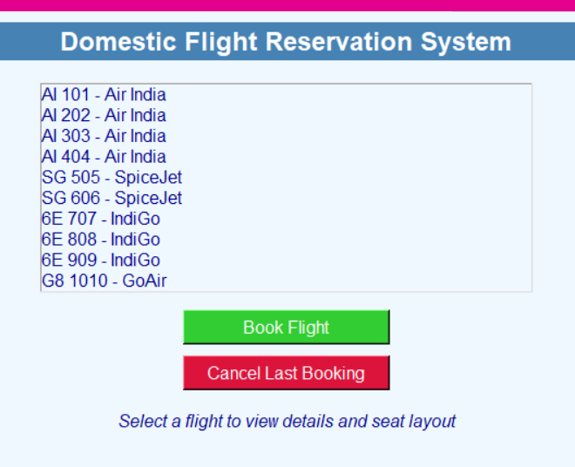

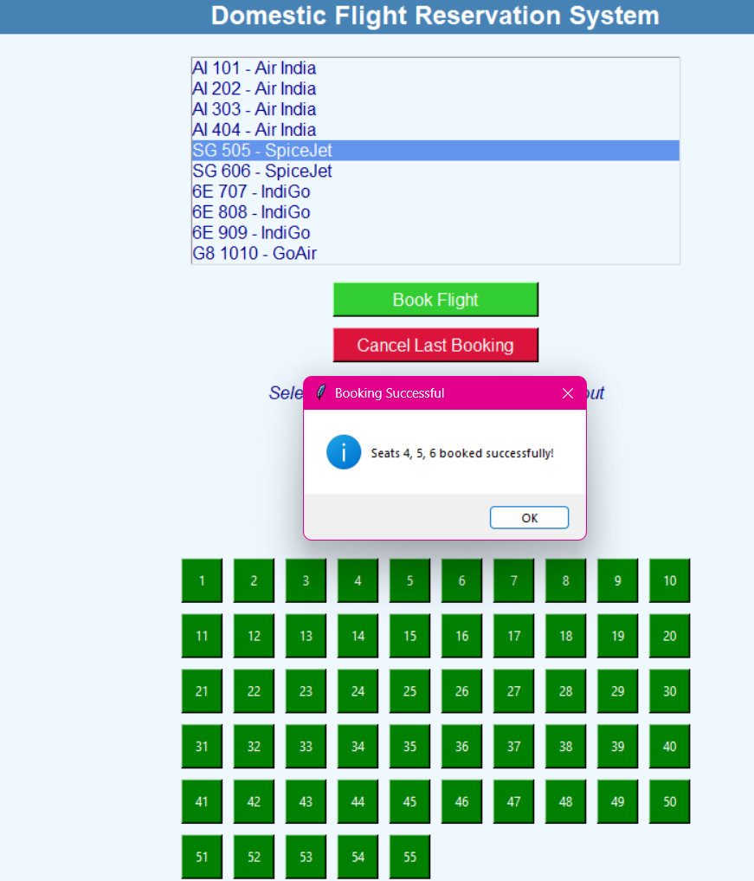 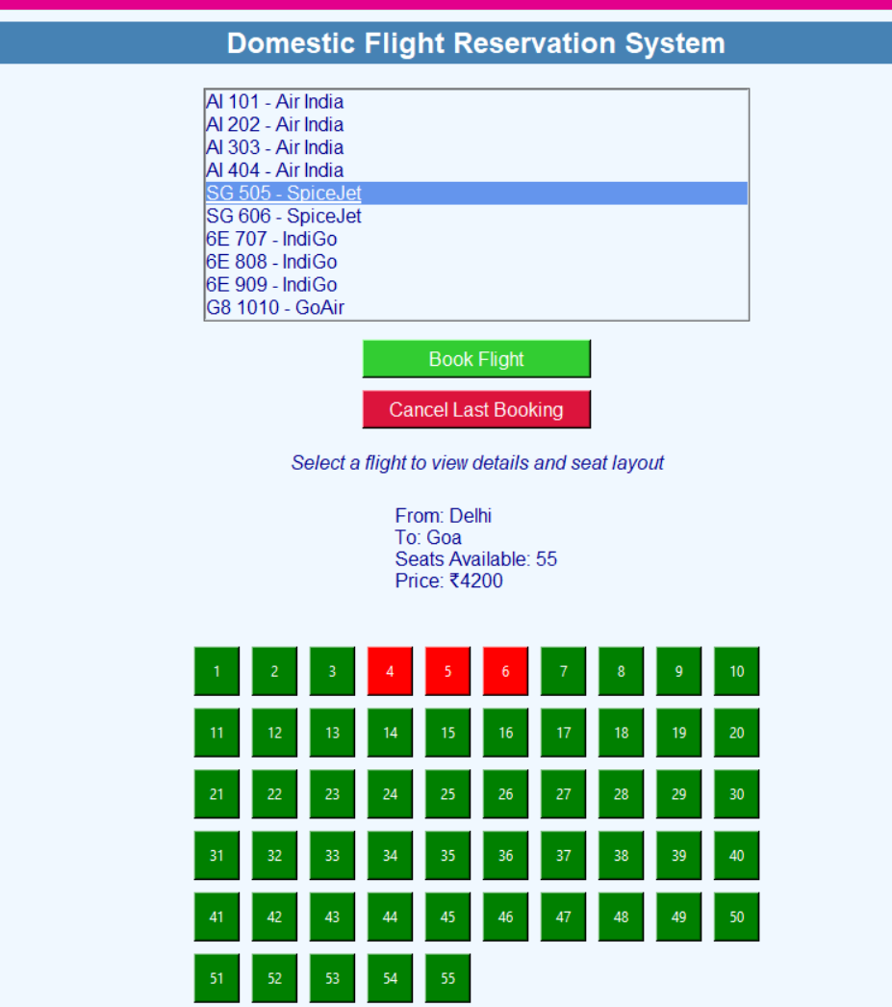

# Conclusion

The Flight Reservation System is a user-friendly and feature-rich application that simplifies flight booking and management. The system allows users to reserve seats, check flight details, and manage their bookings with ease. By using a modern GUI and efficient algorithms, the system ensures smooth user experience and fast seat management.